DIGITAL GFT

Big Data

PROJECT SIMULATION

GROUP-A

Md. Sabir -

Shweta L - 11607320

Akshita Johri - 11611168

Amit Srivatsa – 11606808

TABLE OF CONTENTS

|  |  |
| --- | --- |
| 1.0 | Abstract |
| 2.0 | Data and MetaData description |
| 3.0 | Architecture |
| 4.0 | Data-Ingestion |
| 5.0 | Data-Analysis |
| 6.0 | Data Visualization |

ABSTRACT

1. What dataset we used
2. How did we ingest the data
3. How was the analysis done based on the ingestion
4. How did we respresnt the analysed data
5. Application jars we built

DATA AND METADATA DESCRIPTION

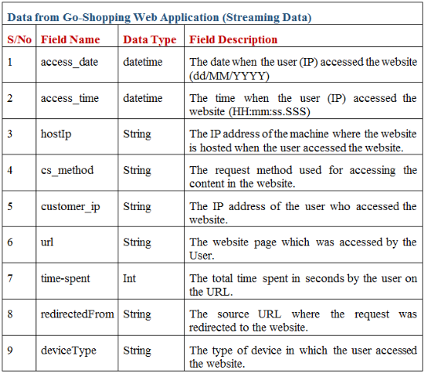



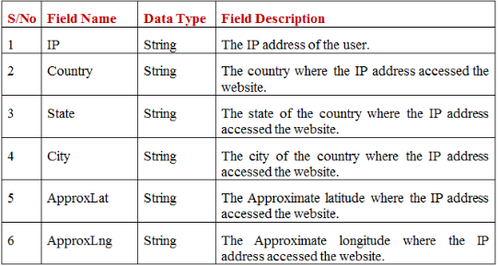

ARCHITECTURE

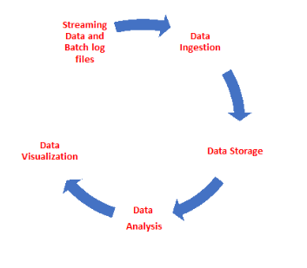

DATA INGESTION

Batch Files

Cassandra :

1. Creating database named “GoShopping”

CODE :

**create keyspace GoShopping with replication ={ 'class': 'SimpleStrategy', 'replication_factor': 1 };**

1. Creating table named “UserIpDetails” and loading the data from goShopping_IpLookup

CODE:

**create table goshopping.UserIpDetails (IP text,Country text,State text,City text,ApproxLat text,ApproxLng text,primary key(IP,Country));**

**copy UserIpDetails(IP,Country,State,City,ApproxLat,ApproxLng) from '/home/vagrant/goShopping_IpLookup.txt';**

HDFs :

1. Creating a “GoShopping” directory
2. Loading the goShopping_IpLookup file to the above directory

Streaming Data

Straming Source to kafka :

1. Creating “goshopping_webclicks” topic with a single replication

Kafka to Hdfs :

1. Spark streaming application to receive message from kafka topic and push it on to HDFS